INTERNATIONAL MARKET AND PRODUCTION OF KAOLIN
Gustavo de Assunção Mello
Directorate of Geology and Mineral Resources
Brazilian Geological Survey
October 2024

1 – CONTEXTUALIZATION

The name "kaolin" comes from the Chinese word “Kauling,” which means "high hill," referring to the Jingdezhen region in China, a historic porcelain-producing area. This term refers to a specific type of clay formed by the alteration of feldspar-rich rocks. Kaolin is predominantly composed of a hydrated aluminum silicate known as kaolinite (Al₂Si₂O₅(OH)₄), which is responsible for the set of physical and chemical properties that make this mineral essential for various industries, particularly chemical and construction industries.

The global kaolin market is primarily driven by industries such as paper, ceramics, paints, coatings, plastics, rubber, and cosmetics. Despite being a versatile mineral, valued for its whiteness, coverage properties, and strength, kaolin has faced challenges in recent years, including the growing demand for synthetic substitutes and environmental concerns. However, the construction and packaging industries continue to drive growth, especially in the Asia-Pacific region, where urbanization keeps the demand for kaolin-based materials high.

Future prospects for the kaolin market indicate moderate growth, driven by technological advancements in beneficiation, expanding applications, and demand from industrial and construction sectors. The market is expected to continue diversifying, with new technologies improving kaolin’s efficiency in industrial applications, making it more competitive compared to alternative materials.

With an increasing focus on sustainable and eco-friendly practices, kaolin is valued as a natural, less toxic mineral compared to other additives, making it an advantageous choice for industries seeking greener alternatives. Among the main industrial sectors expected to support sustained demand for kaolin in the coming decades are:

- Paper Industry: Kaolin is widely used in the paper industry as an additive to improve opacity, smoothness, and strength. While demand for some paper types is declining, segments like packaging paper and cardboard are rapidly growing, reflecting shifts in consumer preferences and the dynamics of the online shopping market;
- Construction Industry: Kaolin is used in building materials, including ceramics, clays, and coatings. Growth in residential and commercial construction, particularly in developing regions, is one of the main drivers of medium-to-long-term demand;
- Plastics and Rubber Industries: Kaolin is increasingly used as a filler in plastics and rubber. As the automotive and consumer goods industries grow, the demand for plastic materials also increases, driving kaolin usage in their formulations;
- Pharmaceutical Industry: The development of new applications for kaolin, such as in cosmetics and pharmaceuticals, is also contributing to increased demand. Its properties, such as smooth texture and absorbency, make it ideal for these products.

These industrial factors combined suggest that the kaolin market will experience consistent growth, but it is subject to challenges related to material substitution and environmental regulations. Companies that invest in innovation and sustainable practices are likely to gain competitive advantages and explore new market segments.

The increasing demand for sustainable alternatives and more responsible mining practices is pushing the kaolin market to adopt new technologies and invest in sustainability, which raises production costs. Growing environmental awareness among consumers and regulators may make eco-friendly processed kaolin more valued in the market, but it also increases pressure on producers to invest in more expensive technologies and responsible mining practices. This scenario creates a challenging and competitive international kaolin market, where economic and political issues play a crucial role in the industry's sustainability and growth.

These issues present challenges for the international kaolin market, directly influencing its supply, demand, and pricing across various industries. Firstly, fluctuations in energy and transportation costs affect the competitiveness of kaolin exports, especially considering that its extraction and processing are energy-intensive. Variations in oil prices and logistics costs can significantly raise the final price, making it difficult for exporters far from major consumer markets to remain competitive.

Trade tensions, regional alliances, tariff barriers, and increasingly stringent environmental regulations in consumer countries like the European Union and the United States may restrict exports by imposing environmental standards and investments that producing countries must meet to access these markets. Brazil, one of the leading exporters, faces challenges related to competitiveness with other major exporters, such as the United States and China, which frequently subsidize their industries or implement protectionist policies.

The reliance on a few large consumer markets is also a delicate issue for the sector, as an economic slowdown in a key country, such as China, could drastically reduce global demand, impacting prices and creating uncertainties for kaolin producers in exporting countries like Brazil and Australia.

The international price of kaolin is influenced by industrial demand as well as global economic conditions. In 2024, major global producers announced price increases of 4% to 10% due to rising production and transportation costs, indicating an upward trend in the global market. Global demand shows stable growth, with an expected annual expansion of approximately 4% until 2029, particularly in the Asia-Pacific region, which leads global consumption due to industrial and infrastructure demand, in line with the increase in applications and the expansion of new markets.

Currently, the international price of kaolin varies by region and type of application. In the United States, the average price was around USD 160 per ton in 2023. This value can be higher for specific types of kaolin, such as calcined kaolin, used in higher-value-added industrial applications, including ceramics and coatings. Kaolin prices are also affected by geopolitical issues and fluctuations in demand from major consumer markets.

The historical price series for kaolin shows a gradual increase over the past decades, reflected in the producer price index (PPI) for the kaolin and clays mining sector, as shown in Figure 1. For example, in the United States, the PPI for these products reached 281.06 points in September 2023, compared to 247.5 points in December 2022, based on an index set in June 1984

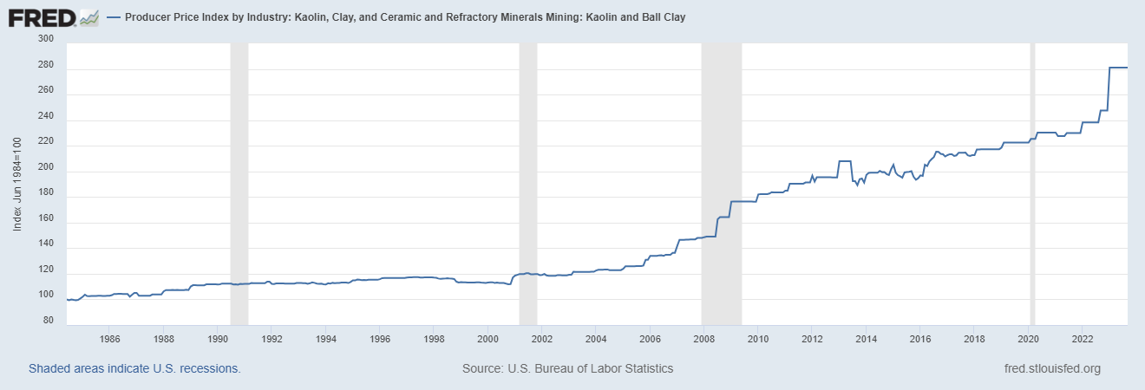
Figure 1: Price Index Variation for Kaolin and Clays (Research Department at the Federal Reserve Bank of St. Louis, 2023)

In Brazil, kaolin prices vary based on its quality and application but are generally aligned with international prices, which ranged from USD 160 to USD 180 per ton in 2023. Companies with large operations in the country, such as Imerys and KaMin, have implemented price increases in both local and global markets, driven by rising production costs. In Brazil, the state of Pará is the leading producer, supplying both the domestic market and exports, especially for the paper and ceramics industries.

2 - ASPECTS OF GLOBAL KAOLIN PRODUCTION

The sale value of kaolin is directly linked to the level of processing and specific application, with products such as high-purity calcined kaolin and cosmetic-grade kaolin frequently leading market prices. Different types of kaolin have various applications depending on their physical and chemical properties, beneficiation, and quality level.

- Raw Kaolin (Unprocessed): Extracted and sold with little or no processing, catering to industries that process kaolin for higher-quality uses;
- Beneficiated Kaolin: Undergoes purification processes that enhance its whiteness and particle size, commonly used in medium value-added products, such as in the construction and cardboard industries;
- Calcined Kaolin: Obtained through heating, this type is highly valued for its thermal resistance and whiteness, with high-value-added applications such as paints, plastics, and cosmetics.

The price of calcined kaolin tends to be significantly higher than that of beneficiated kaolin due to the additional processing involved. On average, calcined kaolin can cost 20% to 50% more than beneficiated kaolin. This higher price reflects the use of calcined kaolin in higher-value applications, such as paints and plastics, where its enhanced properties are required, compared to beneficiated kaolin, which is used in paper and ceramics.

The enhanced thermal resistance and chemical stability make calcined kaolin indispensable in industries where strength and stability are crucial, which other types of kaolin cannot provide.

- High-Quality Paints and Coatings: Used to improve opacity and resistance to high temperatures, making it ideal for industrial and architectural coatings that require greater durability;
- High-Strength Plastics and Rubbers: Acts as a reinforcement, improving mechanical properties;
- Catalysts and Refractories: In processes requiring thermal and chemical resistance, such as advanced ceramics and in chemical industries.

However, not all kaolin extracted from mines is suitable for the calcination process. To be calcined, kaolin must have specific characteristics, such as low impurity content, good whiteness, and fine particle size, making the process unfeasible for kaolin with high contaminant levels. Thus, mineral assets with kaolin deposits possessing these characteristics are considered more valuable in the mining project market.

The production cost of calcined kaolin is generally higher compared to beneficiated kaolin due to the additional calcination process, which involves the use of high temperatures and more energy. Calcination improves its physical properties, such as thermal resistance and whiteness, but also incurs additional energy and equipment maintenance costs. In terms of costs, the production of calcined kaolin can add between $70 to $200 per ton to the base cost of beneficiated kaolin, depending on the specific process used and operational efficiency.

The largest kaolin-producing region in the world is North America, with the United States, particularly the state of Georgia, being the largest kaolin producer in the United States and one of the largest in the world. This region is known for producing high-quality kaolin, with ideal characteristics for the paper and chemical industries. Georgia's mining companies primarily produce refined and calcined kaolin, exporting it to various global markets.

In addition to the United States, other countries are prominent kaolin producers worldwide:

- Brazil: One of the leading kaolin producers, especially in the state of Pará. Brazilian kaolin is valued for its high whiteness, making it ideal for coated papers, ceramics, and paints. Brazil is also a major exporter, with much of its production destined for European and U.S. markets;
- China: Has significant kaolin production, concentrated in the provinces of Guangdong, Fujian, and Jiangxi. Although much of the Chinese kaolin is used domestically, the country also exports to other nations, primarily for ceramics, paper, and construction materials;
- Germany: One of the main kaolin producers in Europe. German kaolin is widely used in the production of ceramics, paper, rubber, and plastics. Additionally, Germany has advanced processing technologies, which improve the quality and value of the final product;
- United Kingdom: Known for producing high-quality kaolin, particularly for the ceramics and paper industries, especially in the Cornwall region. British kaolin is well-accepted in the international market due to its whiteness and purity;
- Australia: Has significant kaolin deposits, especially in the Western Australia region.

In Latin America, some countries also extract and commercialize kaolin, such as Argentina, Chile, Colombia, and Mexico. Although they are not large producers like Brazil, they have kaolin extraction operations that meet local demands and, in some cases, serve export markets.
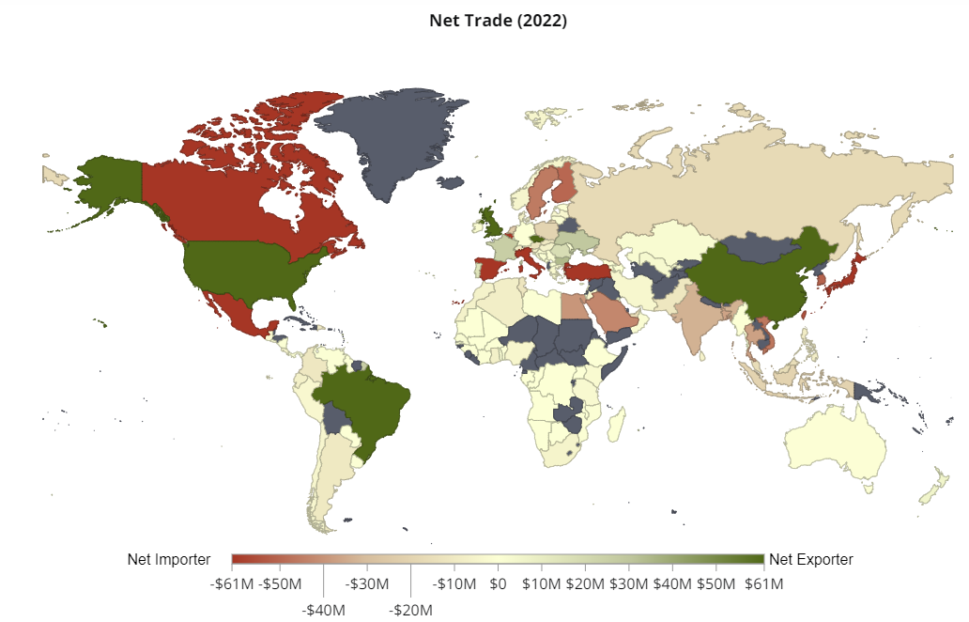
Figure 2: Main Exporting and Importing Countries of Kaolin (The Observatory of Economic Complexity-OEC, 2022)

Among the companies, the top ten kaolin producers worldwide include Imerys (France), KaMin LLC (USA), BASF (Germany), Sibelco (Belgium), Thiele Kaolin Company (USA), EICL (India), Quarzwerke GmbH (Germany), Shree Ram Minerals (India), Sedlecky Kaolin (Czech Republic), and Ashapura Group (India). These companies dominate the global market, supplying kaolin to various industries and increasing investments in extraction, beneficiation, and sustainability technologies to meet the growing demand in line with evolving environmental regulations.

Imerys, the global market leader, operates in over 50 countries and recently sold its Kaolin operations to the Flack investment group, based in the USA. KaMin LLC is known for its specialization in kaolin for paper and coatings, and in 2022, it acquired BASF’s mining segment. Sibelco has a strong presence in Europe, supplying high-quality products, and Thiele Kaolin stands out in North America for its sustainable mining practices. Indian companies, such as EICL and Ashapura, leverage their strategic position in Asia for exports, providing competitive products globally. These companies ensure the competitiveness of the market and the global supply of kaolin, serving various essential industries.

Specifically in China, there are numerous small and medium-sized mining companies operating several mines in regions rich in high-quality kaolin deposits, catering to both domestic and export markets.

Currently, three new kaolin mines are under development:

- Alekseevskoye Kaolin Deposit (Kazakhstan): Qazaq Kaolin is planning to launch a new plant in 2026 at the Alekseevskoye deposit, which previously had a mining and processing complex during the Soviet era. The new facility will have a production capacity of 90,000 tons of enriched kaolin per year;
- Wickepin Kaolin Project (Australia): The project, located near Perth, was commissioned in September 2022 and has the potential to become one of the largest sources of premium kaolin in the world. With estimated reserves of 64.9 million tons, the project focuses on producing high-quality kaolin for various industries;
- Tampu Kaolin Project (Australia): The Tampu project, developed by Corella Resources, has indicated mineral resources of 24.7 million tons and is being developed to supply high-purity kaolin, with potential applications in ceramics, cosmetics, and pharmaceuticals.

3 - ASPECTS OF DOMESTIC KAOLIN PRODUCTION

In Brazil, kaolin production is primarily concentrated in the state of Pará, which holds large reserves and high-quality deposits, especially in the Rio Capim region. Other production areas include the states of Minas Gerais, São Paulo, Santa Catarina, and Rio Grande do Sul, though on a smaller scale.

Pará is also Brazil’s main producer of calcined kaolin, where large companies such as IMERYS and CADAM have the infrastructure and adequate reserves for this type of beneficiation. Minas Gerais also has units processing calcined kaolin, albeit on a smaller scale, meeting specific industrial sector demands.

The Imerys kaolin mine in Brazil is located in the Rio Capim Basin region in Ipixuna do Pará, Pará state. Operated by its subsidiary Imerys Rio Capim Caulim Ltda., recently sold to the Flacks Group, this unit is one of the largest in the country and focuses on the extraction and beneficiation of kaolin. Imerys has a robust infrastructure in the region, including processing facilities and a logistics terminal at the Vila do Conde port, facilitating the transport and export of both beneficiated and calcined kaolin to various international markets.

Meanwhile, CADAM S.A., operated by KaMin LLC, has a major operation located in the municipality of Muaná, on Marajó Island, also in Pará state. The company extracts kaolin from this mine and operates a beneficiation plant near the extraction area. Additionally, CADAM uses the Vila do Conde port in Barcarena to export its product, supplying both domestic and international markets, primarily for the paper industry.

Three other small-scale companies also produce calcined kaolin in Brazil:

- Brasclay: Specializes in the production of calcined and hydrated kaolin, although it does not own its own kaolin mine. Instead, the company purchases raw kaolin from suppliers and carries out beneficiation processes, including calcination and hydration, at its facilities;
- Minérios Ouro Branco: Produces calcined kaolin mainly for the coatings sector, where the mineral is valued for its high whiteness and opacity properties;
- SBS Minérios: Located in São Paulo state, this company offers calcined and beneficiated kaolin, focusing on industrial applications such as plastics and rubber, where high thermal resistance and chemical stability are required.

In the southeastern region of Brazil, kaolin production occurs on a smaller scale, with a focus on raw or beneficiated kaolin used in sectors such as ceramics and paper, complementing the supply from the major producing companies. Minas Gerais and São Paulo also produce calcined kaolin, which, while not as significant as in Pará, meets part of the national demand for this specific type of kaolin.

In southern Brazil, kaolin production is concentrated in Santa Catarina and Rio Grande do Sul, with extraction primarily targeting the local market, with industrial applications focused on ceramics, paper, and coatings. Local companies beneficiate the mineral to meet the demands of these lower-volume sectors.

In the northeastern region, kaolin production occurs primarily in Maranhão and Paraíba. In Maranhão, kaolin is mainly extracted for export, supplying the paper and ceramics industries. In Paraíba, particularly in the Junco do Seridó region, kaolin extraction and beneficiation operations serve mainly the domestic market. In Bahia, there are some kaolin deposits in regions such as Iguaí and Vitória da Conquista, where the mineral is extracted and primarily used for local applications. Bahia's production is generally directed towards the ceramics industry and, to a lesser extent, other sectors that use beneficiated kaolin. Although kaolin production in the northeastern region is not as significant as in other areas, it plays an important role in local and regional supply

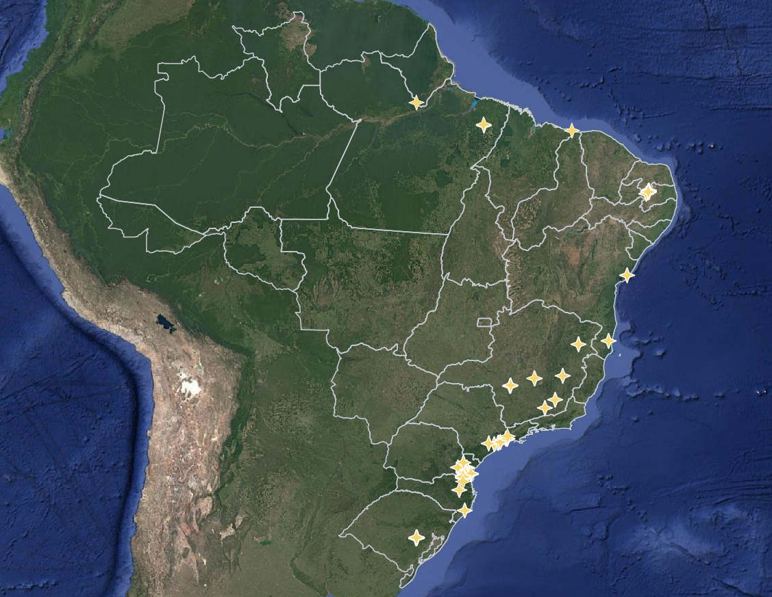
Figure 3: Location of Kaolin Mines in Brazil (ANM, 2023)

4 - INTERNATIONAL TRADE OF BRAZILIAN KAOLIN PRODUCTION

Brazil is one of the largest exporters of kaolin in the world, particularly recognized for the quality and purity of its product, which is used in various industries. Brazilian kaolin, primarily extracted in the state of Pará, serves a significant portion of the global market for paper, ceramics, paints, and rubber. Companies such as Imerys Rio Capim Caulim and CADAM play a key role, representing the majority of national production.

Approximately 85% of Brazil's kaolin production is exported, with Europe, North America, and Asia being the main consumer markets. The high-brightness, low-impurity kaolin found in the mines of the Amazon region makes Brazilian kaolin highly competitive and valued in these consumer markets, particularly for applications requiring these properties, such as high-performance coatings and additives in plastic compounds. In the domestic market, kaolin is primarily used in the paper and construction industries.

Belgium, the United States, Japan, China, and the Netherlands are among the main importers of Brazilian kaolin, with Belgium alone accounting for around 30% of exports. Brazil's strategic position and investments in logistical infrastructure, such as ports and slurry pipelines, facilitate access to international markets, solidifying the country as a major player in the global market for beneficiated and calcined kaolin.

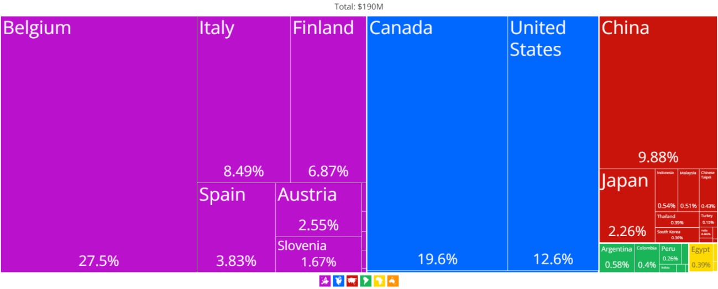
Figure 4: Countries Importing Kaolin Produced in Brazil (The Observatory of Economic Complexity-OEC, 2022)

Globally, the top five kaolin-importing countries are:

- Japan: Imports about 8.3% of the world's kaolin, used mainly in the paper and ceramics industries.
- Germany: Represents approximately 7.5% of global imports, with applications in the paints and rubber industries.
- Belgium-Luxembourg: Imports around 7.4%, mainly serving the construction and paper sectors.
- Finland: Accounts for 6.4% of imports, primarily used in the production of high-quality paper.
- China: Imports 6.2%, using kaolin in various industries, including paper, ceramics, and cosmetics.

5 - RIO CAPIM KAOLIN DEPOSIT (CPRM-SGB)

The Rio Capim kaolin deposit, owned by CPRM - SGB, contains high-brightness material with low impurity levels, critical characteristics for high-quality beneficiation of this mineral resource. These properties make the deposit potentially suitable for the production of calcined kaolin, as the calcination process requires kaolin with low iron and titanium oxide content, which can affect the color and desired properties of the final product.

This CPRM-SGB mineral asset is located in the Rio Capim region, in the municipality of Ipixuna do Pará, in the state of Pará. This reserve is one of the largest in the country, covering approximately 10,000 hectares, divided into two main blocks: the Northern Block and the Southern Block. It is estimated that the Northern Block holds about 574 million tons of kaolin, while the Southern Block contains 218 million tons. In total, the resource volume amounts to around 800 million tons of kaolin.

These reserves consist of two types of kaolin: soft kaolin, which has a low sand content, and sandy kaolin. The project was developed to support the mining sector and generate regional investments, promoting both economic development and local job creation. The existing logistical infrastructure, including waterway transport, facilitates the flow of ore to domestic and international markets.

Detailed information on the Rio Capim Kaolin project is provided in the technical presentation attached to this document.

6 – FINAL CONSIDERATIONS

The global kaolin market has shown moderate but consistent growth, driven by demand in sectors such as paper, ceramics, paints, and cosmetics. Currently, most of the global consumption of kaolin is concentrated in Asia and Western Europe, with Belgium, Japan, and China standing out.

Brazil is one of the major players in this market, distinguished by both the quality of its product and its export capacity, with more than 85% of its production geared toward foreign markets. The main Brazilian reserves are located in the state of Pará and are recognized for their high purity and efficient beneficiation processes, securing a competitive position in the international market.

The anticipated increase in global demand for kaolin in the medium and long term presents a positive outlook for the auction of the CPRM-SGB's Rio Capim Kaolin asset. In addition to the two large companies with operations in Brazil, Imerys and CADAM, potential bidders for this project may include:

- Medium-sized mining companies already operating in Brazil, such as ARGISUL MINERAÇÃO, EMPRESA DE MINERAÇÃO HORII, and MINERAÇÃO CASAGRANDE, which could be interested in expanding their operations to increase production capacity or diversify their asset base.
- Brazilian companies without their own mines but producing calcined kaolin, cement, and construction products, such as BRASCLAY, MINÉRIO OURO BRANCO, and SBS MINÉRIOS, may also seek to secure kaolin supply for use in mixtures and coatings.

Foreign mining companies that may be interested in acquiring the Rio Capim Kaolin project include global industrial minerals corporations, particularly from Australia. Below are some of the key companies that could be interested in acquiring or investing in kaolin projects in Brazil, in addition to IMERYS and CADAM (KaMin):

- Andromeda Metals (Australia): A company highly involved in the kaolin sector, specifically in high-purity kaolin projects for high-value applications such as premium ceramics and cosmetics. Andromeda already has significant kaolin projects in Australia, and given its focus on quality minerals and global interest in kaolin, it may be interested in expanding its operations in Brazil, which offers high-quality kaolin and strong export opportunities.
- Mineral Commodities Ltd. – MRC (Australia): A mining company with diversified operations in industrial minerals, including graphite, heavy minerals, and kaolin projects. The company has been seeking global opportunities for expansion in industrial commodities, and with growing interest in kaolin for use in ceramics, cosmetics, and paper, MRC could view Brazil as a strategic location to expand its production base.
- Altech Chemicals (Australia): A mining company focused on the development of high-purity alumina (HPA) projects, which are used in battery industries and other technological sectors. Although its main focus is HPA, the company has shown interest in related materials, such as kaolin, due to the similar properties used in alumina production. A kaolin project in Brazil could complement its HPA production strategy, as high-quality kaolin can be a source of alumina.
- Suvo Strategic Minerals (Australia): Focused on developing and producing kaolin and silica, this company could be interested in expanding its global kaolin supply capacity to meet growing demand in the paper, ceramics, and cosmetics markets. Given its specific focus on kaolin, Suvo could be very interested in acquiring or investing in projects in Brazil, which offers some of the largest and purest kaolin reserves in the world.
- Corella Resources (Australia): A company focused on exploring and developing high-purity kaolin deposits. Given the growing global demand for high-quality kaolin, it may seek to acquire projects in other countries, such as Brazil, to diversify its production sources and increase its export capacity.
- WA Kaolin (Australia): Exclusively focused on kaolin production, with a major kaolin project in Western Australia, exporting kaolin to several international markets. It could seek to increase its global presence by acquiring kaolin projects in Brazil, taking advantage of the high quality of Brazilian reserves and access to new consumer markets in Europe and North America.
- Iluka Resources (Australia): One of the largest industrial minerals miners in Australia, focusing on heavy minerals like zircon and titanium, but also with interests in kaolin. The company has experience in global operations and could be interested in expanding its presence in the kaolin market, particularly in a country like Brazil, which has large reserves and strong export opportunities.
- Thiele Kaolin Company (United States): A major player in the international kaolin market. Although its operations are more concentrated in the North American market, it may seek geographical diversification and new sources of high-quality kaolin, like those found in Brazil.
- Sibelco (Belgium): A multinational company specializing in mineral materials and industrial solutions. The company operates globally and is present in over 40 countries. As one of the largest companies in the industrial minerals sector, Sibelco may be interested in expanding its presence in Brazil, especially given the growing importance of kaolin in strategic industries.

Considering the growing global demand for industrial minerals and increasing environmental regulations that may enhance the value of high-quality mineral resources with reliable origins, companies based in the major importers of Brazilian and global kaolin, such as Belgium, Japan, Germany, China, Canada, Finland, the United States, and Italy, along with international investor funds and private equity firms focused on commodities and mining, may be interested in acquiring and developing a kaolin project with market-desired characteristics.

Additionally, industrial sectors that depend on high-quality kaolin to ensure the production of goods requiring minerals with special properties may show interest in a mineral resource with high brightness and low impurities that will ensure an essential raw material for their production lines. Among these industries are:

- Companies producing chemical inputs and high-performance materials, including additives and composites, may be interested in securing the supply of kaolin used in high-demand industrial specialties.
- Manufacturers of high-value-added products, such as high-quality papers, especially for printing and sophisticated packaging, high-strength plastics, refractories, and cosmetics, may seek to invest directly in the source of calcined kaolin to ensure the supply of a high-performance material with high purity and consistency, aiming to reduce costs with intermediary suppliers.

LIST OF THE WORLD'S LEADING KAOLIN PRODUCING COMPANIES:

IMERYS (FRANCE)
https://www.imerys.com/pt-br/brasil
https://flacksgroup.com
In July 2024, Imerys sold its Latin American operations to the Flacks Group
KAMIN (US)
https://www.kaminllc.com
KaMin is the parent company of CADAM
SCR-SIBELCO N.V. (BELGIUM)
https://www.sibelco.com/en
THIELE KAOLIN COMPANY (US)
https://www.thielekaolin.com
ACTIVE MINERALS INTERNATIONAL (US)
https://activeminerals.com
ASHAPURA GROUP (INDIA)
https://www.ashapura.com
EICL LIMITED (INDIA)
https://eicl.in
20 MICRONS LIMITED (INDIA)
https://www.20microns.com
I-MINERALS (CANADA)
https://imineralsinc.com
ANDROMEDA METALS (AUSTRALIA)
https://www.andromet.com.au
WA KAOLIN (AUSTRALIA)
https://wakaolin.com.au/
CHINA CLAY CO (CHINA)
https://kaolincn.en.alibaba.com
Also known as China Kaolin Clay Co
JIANGXI SINCERE MINERAL INDUSTRY (CHINA)
http://en.jxscky.com
CHINCHANA CHINA CLAY (CHINA)
https://www.chinchanagroup.com
QUARZWERKE GMBH (GERMANY)
https://www.quarzwerke.com/en/
LASSELSBERGER GROUP (HUNGARY)
https://www.lasselsberger.com/en/minerals-2
SEDLECKÝ KAOLIN A.S. (CZECH REPUBLIC)
https://sedlecky-kaolin.cz/en

LIST OF THE MAIN KAOLIN PRODUCING COMPANIES IN BRAZIL:

Kaolin Mining Companies

IMERYS RIO CAPIM CAULIM S.A. (Pará)
https://www.imerys.com/pt-br/brasil
CADAM S.A. (Amapá)
https://www.kaminllc.com/plantsandoperations.html
ARGISUL MINERAÇÃO LTDA (Rio Grande do Sul)
https://argisul.com.br
INDÚSTRIA DE CALCÁRIOS CAÇAPAVA LTDA (Rio Grande do Sul)
https://www.inducal.com.br
EMPRESA DE MINERAÇÃO HORII LTDA (São Paulo)
https://www.mineracaohorii.com.br
MINERAÇÃO CASAGRANDE LTDA (Santa Catarina)
https://casagrandemineracao.com.br
INCONGEL INDÚSTRIA E COMÉRCIO DE MINERAIS NÃO METALICOS LTDA (Paraíba)
https://www.incomgel.com.br
SOCIEDADE CAOLINITA LTDA (São Paulo)
http://www.caolinita.com.br
M.B.M. MINAS BRASIL MINÉRIOS LTDA (Minas Gerais)
https://mbmminerios.com.br

Companies Manufacturing Beneficiated and Calcined Kaolin

BRASCLAY MINERAÇÃO (São Paulo)
https://www.brasclay.com.br
MINÉRIOS OURO BRANCO (São Paulo)
http://www.ourobranco.com.br
SBS MINÉRIOS (São Paulo)
https://sbsminerios.com.br
BRASILMINAS (São Paulo)
https://www.brasilminas.net
BRANCAL (Minas Gerais)
https://brancal.com.br
MINAS SILICIO (Minas Gerais)
https://www.minasilicio.com.br
GLOBAL MINÉRIOS (São Paulo)
https://www.globalminerio.com.br

Kaolin Mining Companies without Websites:
MOHAWK REVESTIMENTOS LTDA (Bahia)
OXFORD MINERAÇÃO LTDA (Santa Catarina)
INCEPA REVESTIMENTOS CERÂMICOS LTDA (Paraná)
MINERAÇÃO FLORESTA LTDA (Santa Catarina)
CERAMINA INDÚSTRIA CERÂMICA E MINERAÇÃO LTDA (Santa Catarina)
MINERAÇÃO JOSE MARCELINO DE OLIVEIRA & CIA LTDA (Rio Grande do Norte)
TERRA MATER PARTICIPAÇÕES E EMPREENDIMENTOS LTDA (Paraná)
MINERAÇÃO GINO MINAS LTDA (Paraná)
TERRA VIVA CONSULTORIA E MINERAÇÃO LTDA (Minas Gerais)
MINERAÇÃO DE CAULIM MONTE PASCOAL S.A. (Santa Catarina)
MINERAÇÃO PORTOBELLO LTDA (Santa Catarina)
CAULINIA MINÉRIOS LTDA (Rio Grande do Norte)
REFERENCED SOURCES:

PROJETO DE REAVALIAÇÃO DO PATRIMÔNIO MINERAL: ÁREA CAULIM DO RIO CAPIM, ESTADO DO PARÁ (2021)
https://rigeo.sgb.gov.br/handle/doc/22403

O CAULIM DO RIO CAPIM (2003)
https://rigeo.sgb.gov.br/handle/doc/312

EXTRAÇÃO MINERAL DE CAULIM: LEGISLAÇÃO, PROCESSO PRODUTIVO E IMPACTOS AMBIENTAIS (2021)
https://periodicos.apps.uern.br/index.php/GEOTemas/article/view/3451

CARACTERIZAÇÃO COMPARATIVA DE CAULINS PARA FORMULAÇÕES DE ENGOBES E ESMALTES CERÂMICOS (2007)
https://repositorio.unesp.br/server/api/core/bitstreams/19e9f078-342b-4384-ae69-cc600d7738bc/content

CAULINS BRASILEIROS: ALGUNS ASPECTOS DA GEOLOGIA E DA MINERALOGIA (1998)
https://www.scielo.br/j/ce/a/YYJnQQJL7G4zK6mjWdkYyHn/#

https://www.sgb.gov.br/leilao-rio-capim-pa-caulim
https://oec.world/en/profile/hs/kaolin
https://fred.stlouisfed.org/series/PCU2123242123240#
https://www.mordorintelligence.com/pt/industry-reports/kaolin-market
https://www.expertmarketresearch.com/reports/kaolin-market
https://www.researchandmarkets.com/reports/5686535/2024-kaolin-market-outlook-report-industry
https://mcgroup.co.uk/researches/kaolin
https://www.nsenergybusiness.com/projects/great-white-kaolin-project/?cf-view
https://wits.worldbank.org/trade/comtrade/en/country/All/year/2023/tradeflow/Imports/partner/BRA/product/250700

