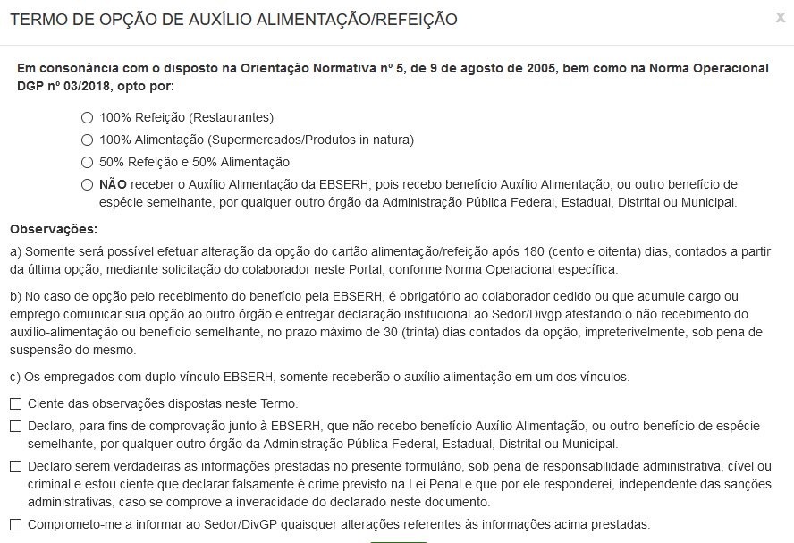

Rio de Janeiro, _______ de ____________________ de ______________.

________________________________________________________________________
Assinatura do Candidato

