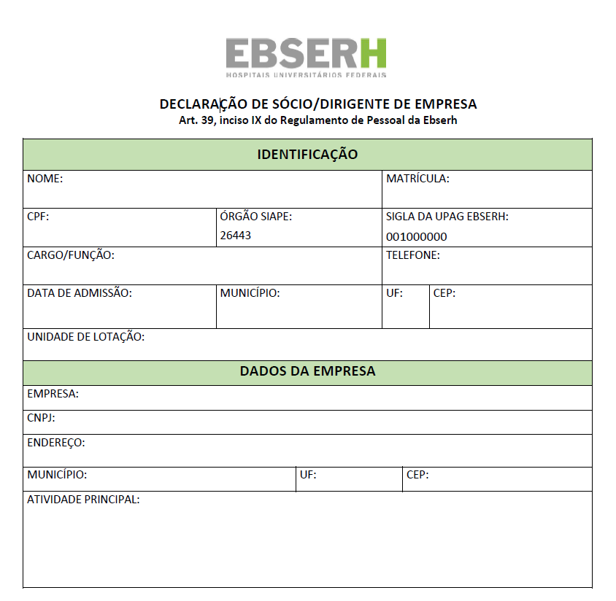
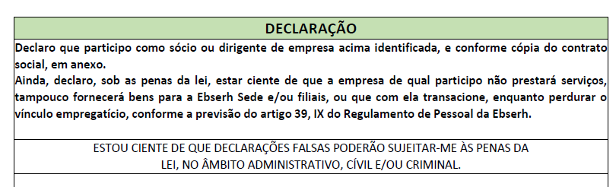

Rio de Janeiro, ______ de ______________________ de ___________.

______________________________________________________________________
Assinatura

