RESTRICTED ACCESS
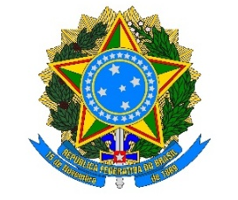
FEDERATIVE REPUBLIC OF BRAZIL
(ISSUING ENTITY)

SECURITY CLEARANCE CERTIFICATE

Security Clearance No.: _________

Full name:
Date of birth:
Place of birth:
Social Security Number (CPF) or Passport No.:
Nationality:
Position or function:
Agency or entity:
Purpose or need-to-know:

This document certifies that the person identified above holds a security clearance for the handling of classified information at the [ULTRASSECRETO / SECRETO / RESERVADO] level, issued by _____(REGISTRY ENTITY RESPONSIBLE FOR ISSUANCE)_____ pursuant to Normative Instruction No. 10, of july 3, 2026.

This certificate is valid until (day) of (month) of (year) .

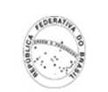
(city / State) , (day) of (month) of 20 .

__________ (FULL NAME)__________
Security and Clearance Manager

RESTRICTED ACCESS

