Guidelines for Obtaining Single Notice Portal - Registration (Foreign Person)

The use of the Single Notice Portal is made upon prior registration. Foreign people (repair station´s representatives) can register following the steps below:

- Access the initial Single Notice Portal in the following link: https://santosdumont.anac.gov.br/menu/r/api/portal_unico_notificacao/selecao-do-tipo-de-notificacao?session=113849434589978

- To access the English version of this page, in the top right-hand corner, select the “English(en)” option by clicking on the globe icon.
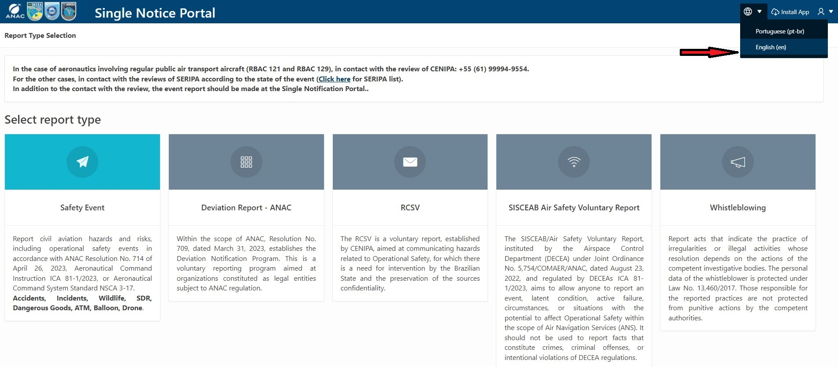

- Then, still in the top right-hand corner, select “Login/Signup” by clicking on the person icon. At this point, you will be redirected to the ANAC website to register with ANAC.
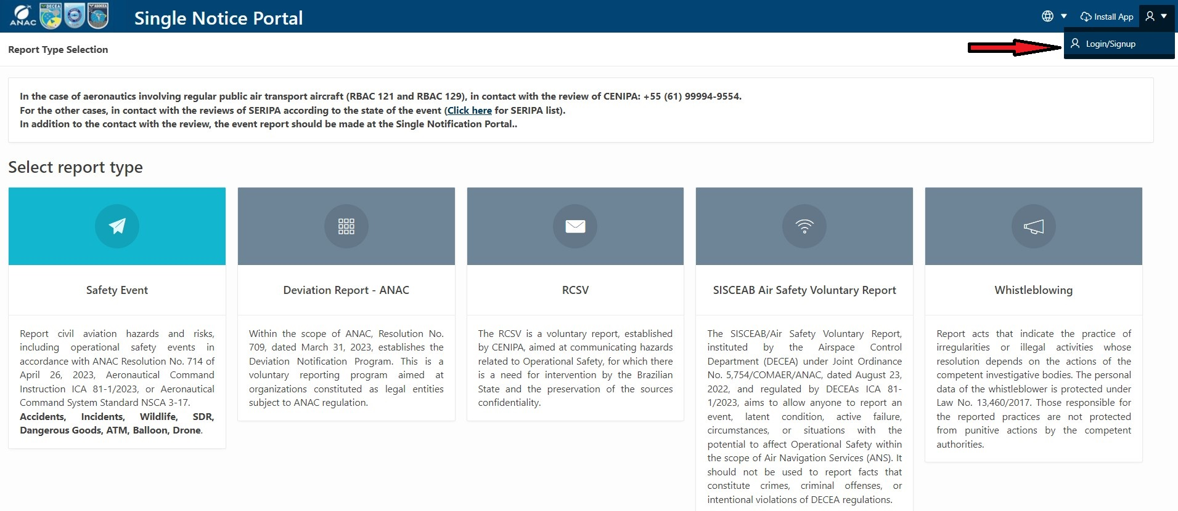

- Select “Sign-in with ANAC”.
Note: Eventually, if the ANAC website opens in Portuguese, you can select the English version by clicking on the globe icon in the top right-hand corner.
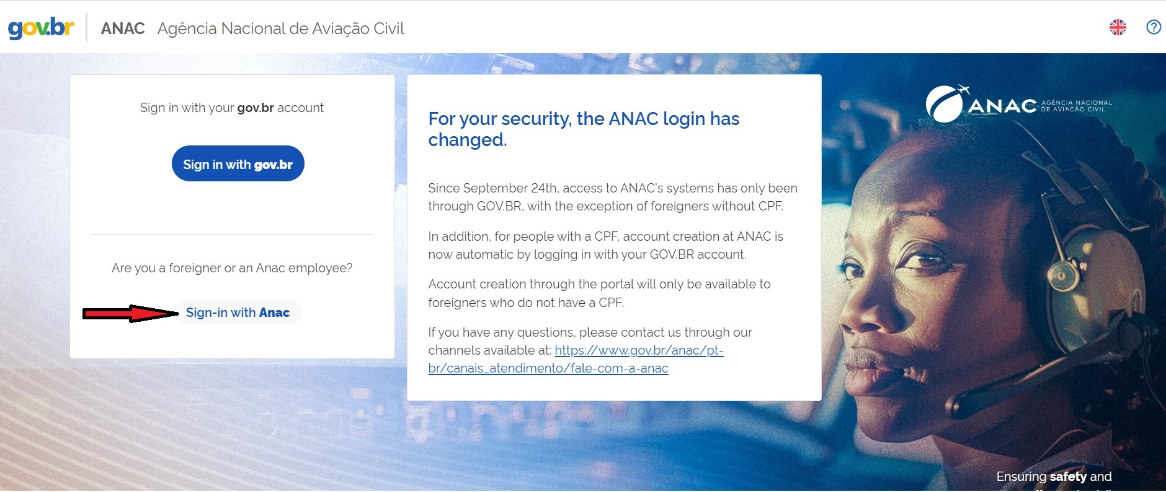

- Select “CREATE ACCOUNT”.
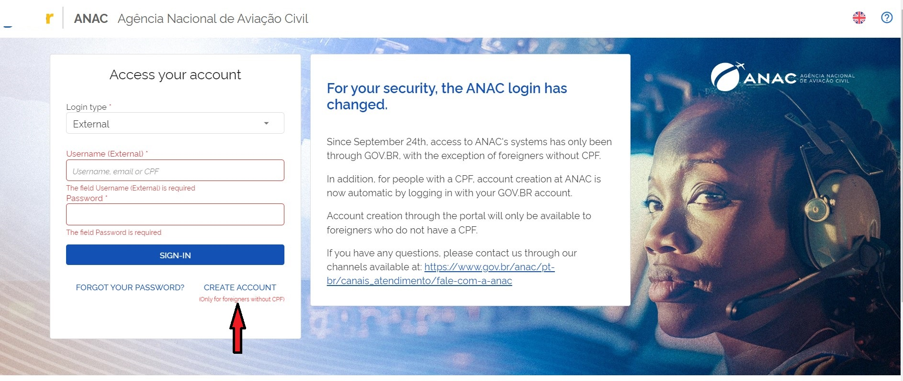

- Fill in the information in the data form and select “CREATE MY ACCOUNT” to finish it.

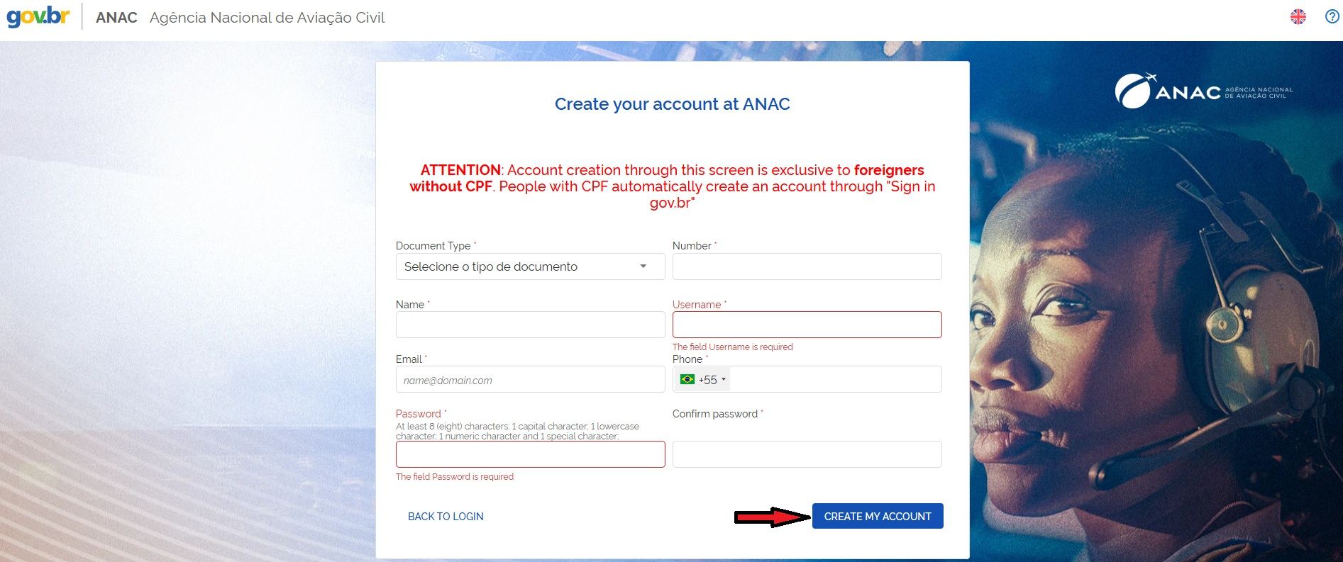

- Now you are ready to use the Single Notice Portal. All you need to do is to follow steps 1, 2, 3 and 4 again; then, on the page below, select “External” in the “Login type” field, fill in your username and password and select “SIGN-IN”.
